Belloula Belkhir Middle School May, 2018

Full name:........................................... Class:1MS..... N...... Duration: 1h

The First Test of English

**Text:**

 Hi, my name is Susan. I am 13 years old. I am a pupil at Wilson School. My school is large and beautiful. It is in London. We have 12 classrooms, a sports ground, 2 physics labs, 2 biology labs, a computer room and a canteen where we have lunch. We have a lovely schoolyard where we play. We study 12 subjects there like: maths, English, Arabic, history, geography…etc. We start lessons at 8 o’clock in the morning and we finish at 4 o’clock in the afternoon. All pupils here are nice and polite.

**Part One: (14 pts)**

**A/ Reading Comprehension(07pts)**

**Activity one : Complete the table with information from the text (04pts).**

|  |  |  |  |
| --- | --- | --- | --- |
| The school’s name | City | Number of classrooms | Number of subjects |
| ……………………… | …………………… | ………………………… | ……………………….. |

**Activity Two: Read the following statements and tick (√) true or false (3pts)**

|  |  |  |
| --- | --- | --- |
| Statement | True | false |
| 1- Susan’s school has 1 physics lab. |  |  |
| 2- Pupils in Susan’s school study 12 subjects. |  |  |
| 3- Lessons start at 4 o’clock in the afternoon. |  |  |

**B/ Mastery of language (7pts)**

**Activity One: Complete the following sentences with ‘from’ , ‘to’ or ‘on’ (3pts).**

A: When do you study English?

B: I study English …… Sunday, …….. 8: 00 a.m ……… 9:00 and ……… Thursday, ……… 3:00 p.m ……… 4: 00 p.m.

**Activity Two: Check the correct box(√)(2pts):**

I do I don’t

chew gum in class.

listen to the teacher.

eat food in class.

respect my friends.

**Activity Three: Write the following words in the right box according to their vowel sound pronunciation (2pts)**

I - speak- read- my

|  |  |
| --- | --- |
| /ai/ hi | /i:/ green |
| ……………. | ……………. |
| ……………. | ……………. |

**Part Two: Written Expression (6pts):**

A new pupil arrived at the school. He wants to know about the location of the following places: **the sports ground, the physics lab and the canteen.** Follow the map and write the dialogue between you and the new pupil.

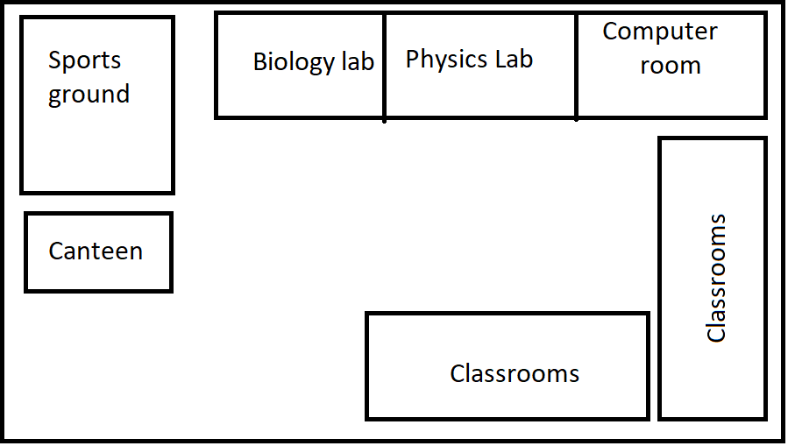

The new pupil: Excuse me, where is the sports ground?

You: ……………………………………………………………………….

The new pupil: ……………………………………………………………..

You: ………………………………………………………………………..

The new pupil: ……………………………………………………………..

You: ………………………………………………………………………..

